**Aufgabe 3**

**1.**

**Homo sapiens chromosome 12, GRCh38.p13 Primary Assembly**

**Gen: NR1H4**

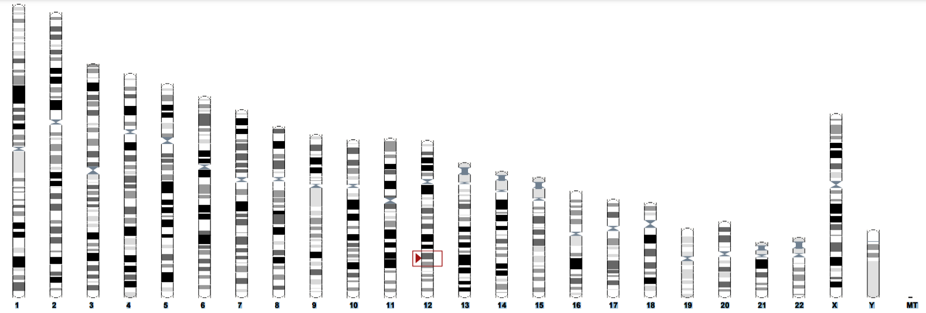

**Homo sapiens interferon lambda 3 (IFNL3), RefSeqGene (LRG_1011) on chromosome 19**

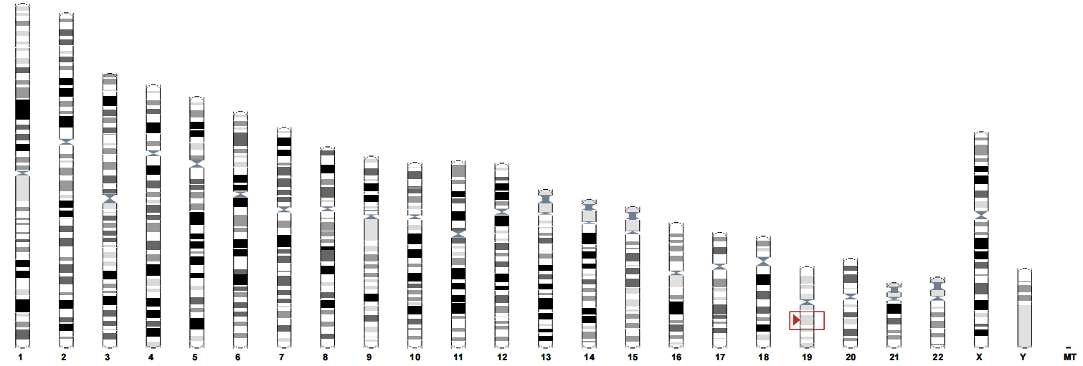

**3.**

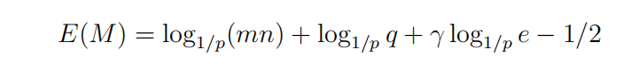



Result: 13,91193